**1. Building “Classifiers”**

Classifiers in WEKA are the models for forecasting nominal or numeric amounts. The learning strategies which are available in WEKA contain

* decision trees and lists
* instance-based classifiers
* support vector machines
* multi-layer perceptrons
* logistic regression.

“Meta”- classifiers include:

1. bagging
2. boosting
3. stacking
4. error-correcting
5. output codes
6. locally weighted learning.

After loading the data set, click the classification tab.  
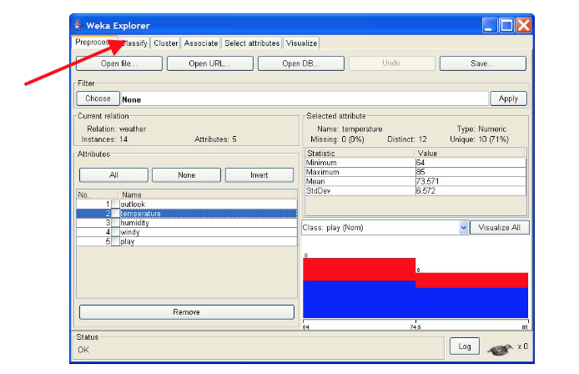

In this workshop, you will analyze the data with C4.5 algorithm using J48 decision tree learner. The sample data used in this exercise is the “weather.arff”.